Hotle_Reservation Project

KPI’s

1. What is the total number of reservations in the dataset?

SELECT COUNT(booking_id) AS total_reservation

FROM transaction_hotle

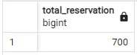

1. Which meal plan is the most popular among guests?

SELECT type_of_meal, COUNT(*) total_num

FROM transaction_hotle

GROUP BY type_of_meal

ORDER BY total_num DESC

LIMIT 1

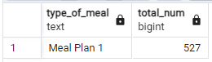

1. What is the average price per room for reservations involving children?

SELECT ROUND(AVG(avg_price_per_room),2) AVG_price

FROM transaction_hotle

WHERE no_of_children <> 0

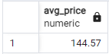

1. How many reservations were made for the year 20XX (replace XX with the desired year)?

SELECT COUNT(*) AS total_reservation_2018

FROM transaction_hotle

WHERE arrival_date LIKE '%2018'

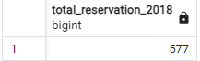

1. What is the most commonly booked room type?

SELECT room_type_reserved, COUNT(*) AS total_num

FROM transaction_hotle

GROUP BY room_type_reserved

ORDER BY total_num DESC

LIMIT 1

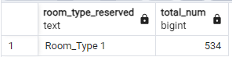

1. How many reservations fall on a weekend (no_of_weekend_nights > 0)?

SELECT COUNT(*) AS total_reservation_weekend

FROM transaction_hotle

WHERE no_of_weekend_nights <> 0

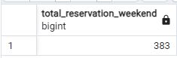

1. What is the highest and lowest lead time for reservations?

WITH cte AS(

SELECT *,

Rank() OVER(ORDER BY leed_time DESC) rnk1

FROM transaction_hotle

)

SELECT DISTINCT leed_time FROM cte

WHERE rnk1 = 1 or rnk1 = (SELECT MAX(rnk1) FROM cte)

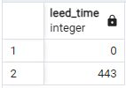

Or

SELECT FIRST_value(leed_time) OVER(ORDER BY leed_time DESC) height_value,

LAST_VALUE(leed_time) OVER(ORDER BY leed_time DESC

RANGE BETWEEN UNBOUNDED PRECEDING AND UNBOUNDED FOLLOWING) lowest_value

FROM transaction_hotle

LIMIT 1;

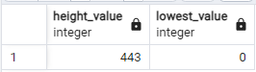

8.What is the most common market segment type for reservations?

SELECT market_segment_type, COUNT(*) Total_num

FROM transaction_hotle

GROUP BY market_segment_type

ORDER BY 1 DESC

LIMIT 1;

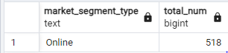

9.How many reservations have a booking status of "Confirmed"?

SELECT booking_status, COUNT(*) Total_num_confirmed

FROM transaction_hotle

GROUP BY booking_status

HAVING booking_status = 'Not_Canceled'

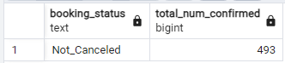

10.What is the total number of adults and children across all reservations?

SELECT SUM(no_of_adults) total_adults, SUM(no_of_children) total_children, SUM(no_of_adults) + SUM(no_of_children) total

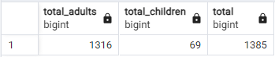FROM transaction_hotle

11.What is the average number of weekend nights for reservations involving children?

SELECT ROUND(AVG((SELECT SUM(no_of_weekend_nights)

FROM transaction_hotle

WHERE no_of_children > 0 )),2) avg_no_of_weekend_nights

FROM transaction_hotle

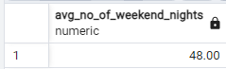

12.How many reservations were made in each month of the year?

1. SELECT MONTH(arrival_date) month_num, COUNT(*) total_reservation
2. FROM hotel_reservation

GROUP BY MONTH(arrival_date)

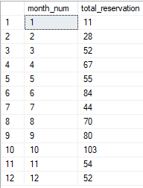

13.What is the average number of nights (both weekend and weekday) spent by guests for each room type?

SELECT room_type_reserved, ROUND(AVG(no_of_weekend_nights) + AVG(no_of_week_nights),2) avg

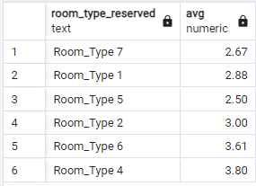FROM transaction_hotle

GROUP BY room_type_reserved

14.For reservations involving children, what is the most common room type, and what is the average price for that room type?

1. WITH cte AS (
2. SELECT TOP(1) room_type_reserved, COUNT(*) total
3. FROM hotel_reservation
4. WHERE no_of_children > 0
5. GROUP BY room_type_reserved
6. ORDER BY 2 DESC)
7. SELECT MAX(avg_price_per_room) height_price
8. FROM hotel_reservation

WHERE room_type_reserved = (SELECT room_type_reserved FROM cte)



15. Find the market segment type that generates the highest average price per room.

SELECT TOP(1) market_segment_type, avg_price_per_room

FROM hotel_reservation

ORDER BY avg_price_per_room DESC

